**Peep Online Group Agreement - Example**

* Confidentiality – what is shared stays in the room, unless we are worried that someone is at risk*
* 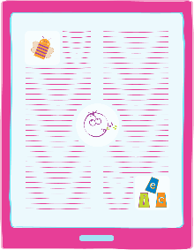We won’t share the group link/ invitation with anyone else
* Phones on silent (or vibrate)
* We will try and stick to start and end times
* We won’t record the session or take screenshots
* We’ll remember that we’re on video, and check that we’re happy with what can be seen ☺
* There are no silly questions – ask for a reminder about how to mute/unmute, turn your camera on/off, change background, message the practitioners or each other, etc
* We’ll respect and support each other, share ideas and have fun!

* If we have any concerns about the safety of you or your child we have a legal duty to pass on our worries to someone who can help. We will not ask your permission if we are worried, but will always tell you what we have done, unless doing so would cause further risk. Our safeguarding policy can be found on our website at …….... or you can contact the office to ask for a copy.